**Final Exam of the 2022-2023 School Year First Term**

**Class: _G11C7_________________________ Name: _林希然Lucas_________________________ No.: ________________________**

装订线（请不要在装订线内答题）

**Beijing 21st Century International School**

**(Subject: English Grade 11 Class 1-7)**

**(Time：90 minutes Total Score：90 points)**

**Answer Sheet**

**Part I-Listening (10*2’=20’) Listen and answer the given questions in grammatically right sentences.**

1. **Some can use Sonar/ Radar to detect or hear things we can’t hear**

**Some can see ultraviolet light.**

1. **The ability is to sense magnetism.**
2. **They should find animals that are attracted by magnets or try to avoid them.**
3. **We can use fruit flies to do experiments.**
4. **They can be trained to set up a magnet near food and then remove the food but move the magnet to another place and see if the fly still flies towards the magnet.**
5. **light**
6. **A molecule that was produced by fruit flies.**
7. **The tested flies can not detect magnetism, because they had lost their photo-receptor in their eyes.**
8. **A photo-receptor can sense Blue and ultraviolet light.**

**10. The photo-receptor got stroked and activated, turning on the magnetic sensory system.**

**Part II-Reading (15*2’+ 10’=40’) Read and answer the given questions in grammatically right sentences and finish the mind-map or summary part in a logical way.**

**1. The southwest’s fundamental problem is the lack of water to obtain and no way to grow crops.**

**2. The rainfall is so low(1) and unpredictable(2).**

**3. They live at higher elevations.**

**4. The Hohokam constructed the most extreme irrigation system.**

**5. “it” in the passage refers to the solution initially adopted by the Mimbres and Pueblo2.**

**6. The cause of the collapse is too many populations with too less food to feed everyone.**

**7. The method in Para4 is to occupy an area for a few decades, then move to another place when the soil became exhausted.**

**8. The strategy was effective only when the population density is low.**

**9. The problem is that when the population densities grow, there will be no areas for them to occupy and the left areas can’t be left unoccupied for that long to recover its nutrition.**

**10. The strategy in Para5 is to plant crops at all the sites and harvest the sites with enough rain, then redistribute some of the harvests to the places lacking rain this year.**

**11. People living in areas that didn’t receive enough rain will be subsidized by other places with enough rain and harvests.**

**12. This strategy requires a complex political and social system to perform such activities.**

**13. The strategy mentioned in para6 is to plant crops and live near permanent or dependable water sources while living above the main floodways to achieve self-sufficiency and not be washed away when a flood passes by.**

**14. The first benefit is to avoid the risk of being washed by the flood when there is one.**

**The second benefit is to exploit ecologically diverse zones to achieve self-sufficient for every zone.**

**15. From my perspective, the organization of the Passage is B(Problem-solution), because the passage is mainly constructed by a problem mentioned in Para1 and solutions discussed in Para2,3,4,5, and 6**

**16. Please summarize the main idea of the whole passage. You can choose one of the three following patterns. (10’)**

(1) Use one or two sentences (about 20 words) to summarize the main idea of each paragraph.

(2) Use one paragraph to summarize the main idea of the whole passage, indicating the relationship between paragraphs (more than 100 words).

(3) Use a mind-map to summarize the main idea of the whole passage, including the key structure and important details.

If you choose option 2, you could get one extra point.

If you choose option 3, you could get two extra points.

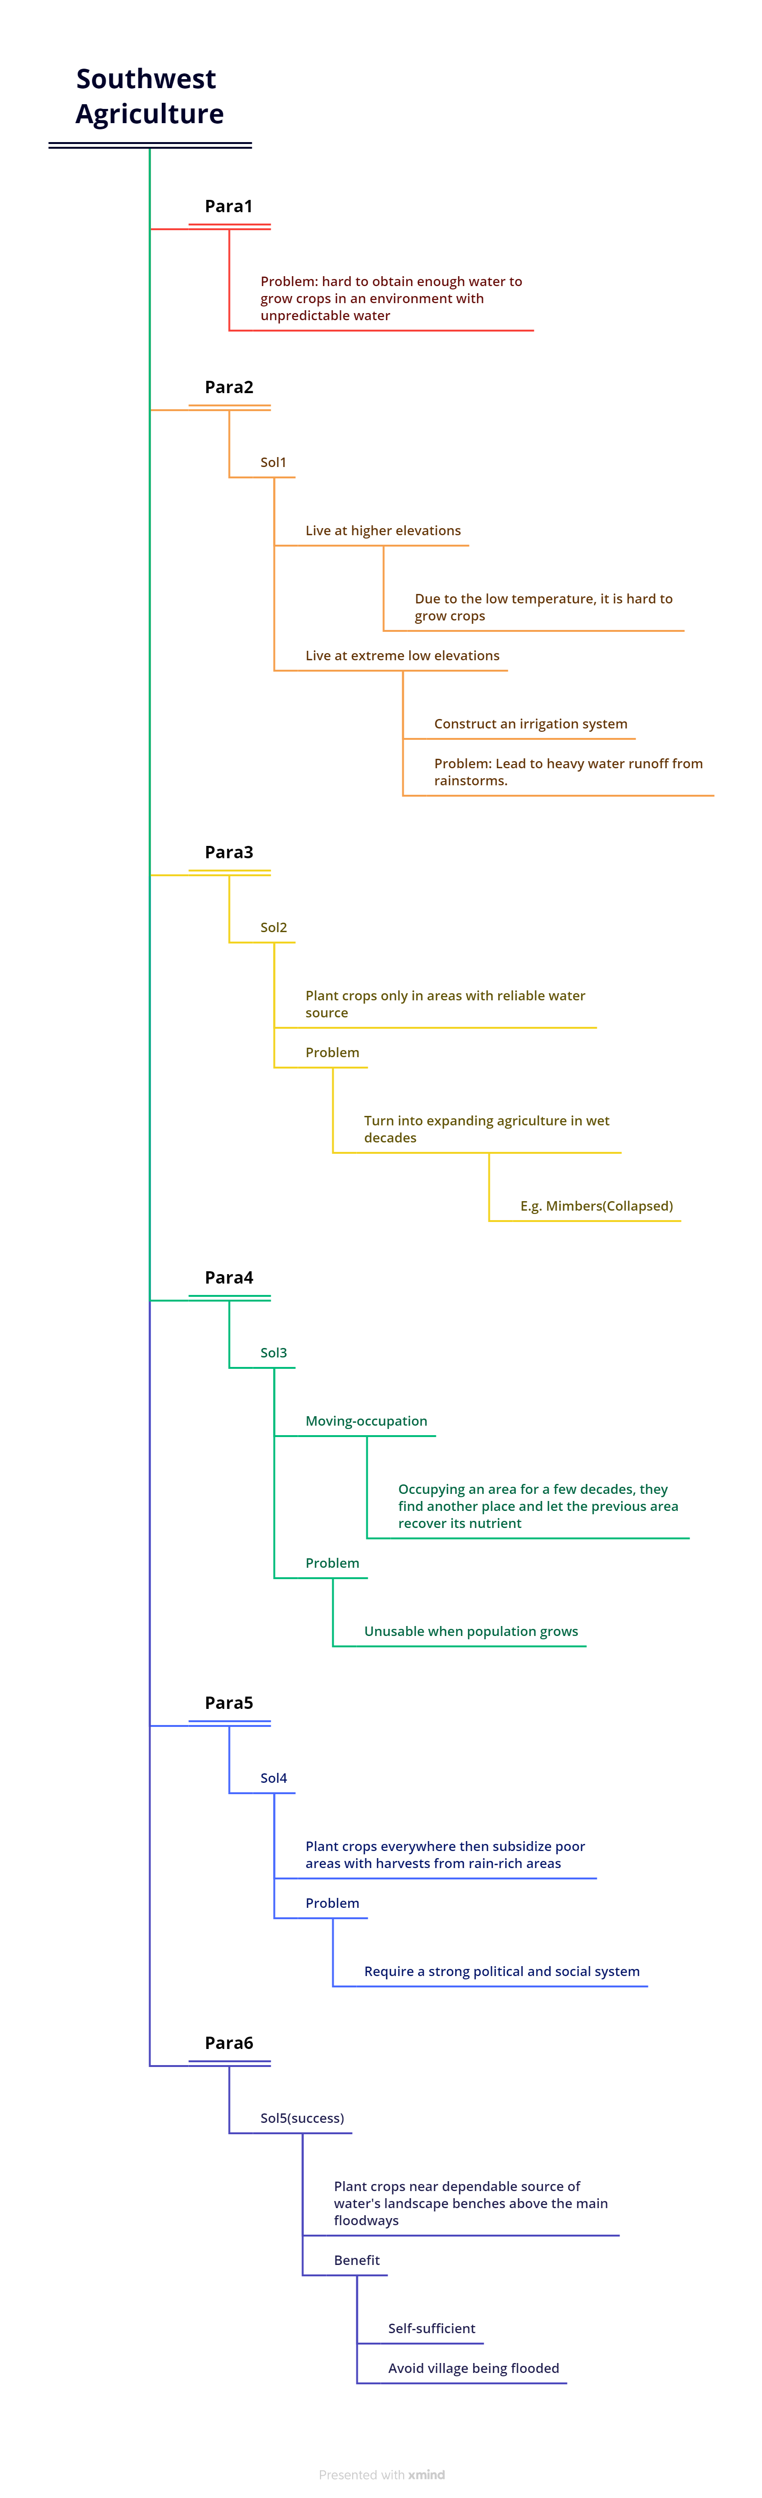

**Part III- Writing (30’)**

**Do you agree or disagree with the following statement?**

**Parents must have strict rules if they want their children to be successful in life.**

**Use specific reasons and examples to support your answer. A minimum of 300 words is required.**

**Since the dawn of human civilization, hardly has been an Era like today that witnesses such fierce competition among human beings. No matter what it is, from physical to mental, from jobs to assets, people have been using whatever they could to push themselves forward to compete with others. However, as an old saying goes in China, “Win at the starting line”, some parents nowadays often put strict rules on their children to let them achieve success in life. However, from my perspective, parents do not need to put strict rules on their children in order to let them achieve success. My reasons are as follows.**

**Firstly, success does not come from anyone else but children themselves. For some children, even if parents put strict rules on them, because of their IQ or other factors, they may never make it into those famous universities. However, if parents put loose rules on them, they may find their advantages in another field rather than studying. Take my Uncle Barter as an example, when he was small, his parents did not put strict rules on him, and although his grade was poor, Barter found himself really good at writing poets and is now working in one of China’s literature facilities. With no strict rules, Barter can still be successful.**

**Secondly, setting strict rules will often kill the chance for children to think independently, while independent thinking is one of the most important things to be successful. Hardly can a person make much money if they can not think and make decisions by themselves. Also, setting strict rules for children can make them more self-disciplined, to have better grades compared to other students among them, but grades and diplomas do not mean everything. The most precious quality that employees value is the ability to think. Take bill gates and Steve jobs as an example, if their parents put strict rules on them, they would not find Microsoft and Apple because they can not think independently, not to say think creatively.**

**Admittedly, playing by strict rules can let children be better at specific aspects, but too strict a rule can also strain the family relationship or even lead to more devastating endings. A recent survey shows that over one-third of the 20,000 people who suicide are due to the pressure their parents give them.**

**From all of the above, it is safe to land the conclusion that parents do not need to put strict rules for their children to success.**